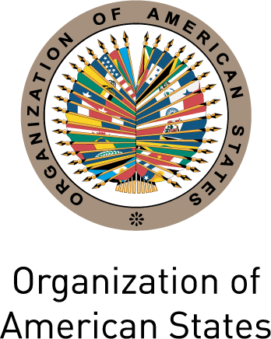


INTER-AMERICAN COMMISSION OF WOMEN

FOURTH MEETING OF MINISTERS OR OF THE OEA/Ser.L/II.7.9
HIGHEST-RANKING AUTHORITIES RESPONSIBLE CIM/REMIM-IV/doc.2/11
FOR THE ADVANCEMENT OF WOMEN IN 27 September 2011
THE MEMBER STATES (REMIM IV) Original: spanish
November 1, 2011
San Salvador, El Salvador
input.doc

AGENDA
(Draft)

- Sixth Summit of the Americas: preparations, objectives, calendar of activities, agenda of the Summit Implementation Review Group (SIRG)

- Conclusion of the civil society Virtual Forum “Connecting the Women of the Americas: Partners for Prosperity”

- Poverty reduction and inequity
- Access to and utilization of technologies
- Security

- Agreements on the integration of gender in the outcome document of the Sixth Summit of the Americas on the issue “Connecting the Americas: Partners for Prosperity”

- Other matters

